1. Mifare Semiconductor (classic, ultralight c) ([Wiki](http://en.wikipedia.org/wiki/MIFARE)) ([mifare cards](http://www.nxp.com/documents/line_card/MIFARE_ICs_939775017001_v9_HR.pdf))
2. **MIFARE Classic 1K** ([nxp](http://www.nxp.com/documents/data_sheet/MF1S503x.pdf), [Skyetek](http://www.skyetek.com/docs/m2/mifareclassic.pdf))

* Employ a proprietary protocol compliant to parts (but not all) of ISO/IEC 14443-3 Type A, with an NXP proprietary security protocol for authentication and ciphering
* RF 13.56 MHZ; communication speed - 106 kbit/s
* P/E cycles - 100000
* Data retention - 10 years
* Anti-collision
* Typical transaction - <100 ms
* Random number generator
* 2 CRYPTO1 keys per sector
* Access condition per sector
* Memory organization:

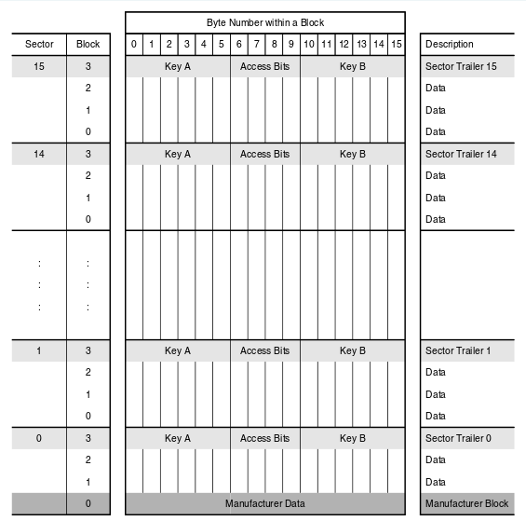

* 1 kB, organized in 16 sectors of 4 blocks (one block = 16 byte)
* 7 bytes UID, 4 bytes Non-UID
* 4 bytes Random ID
* 16 bits CRC per block
* Parity bits for each byte
* Manufacturer data - 16 bytes (sector 0 block 0, 4 bytes NUID)
* Data storage - 3 blocks of each sector, only 2 blocks for 1st sector

total = 15*3+2 = 47 blocks = 47*16 = 752 bytes

* Data block - value block + r/w block (Used to store users data)
* Value block - (This block is used to store data. Commands like read, write, increment, decrement, restore, transfer are performed in this area)

memory = 12 bytes value + 4 bytes address

value = 4 bytes --- 2 times non-inverted, 1 time inverted

addr = 1 bytes --- 2 times non-inverted, 2 times inverted

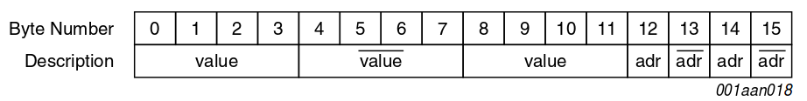

This is done for data integrity and security

* Sector trailer - last block of each sector (Key A + Access bits + Key B)
* Sector trailer contains

1. secret keys A and B (optional), which return logical “0”s when read and
2. the access conditions for the blocks of that sector, which are stored in bytes 6...9. The access bits also specify the type (data or value) of the data blocks.

* Key A + Key B = 6+6 bytes; Access = 4 bytes

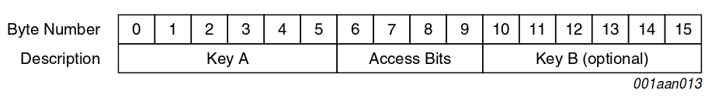

* All keys are set to FFFFFFFFFFFF at chip delivery
* Access Bits description

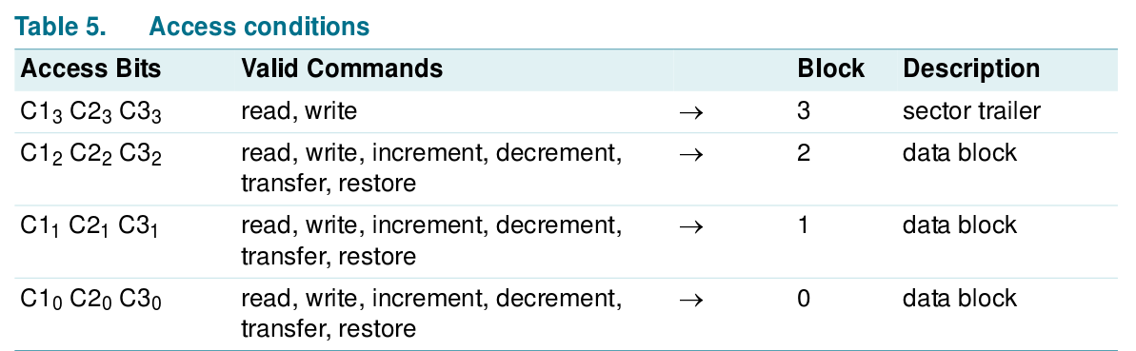

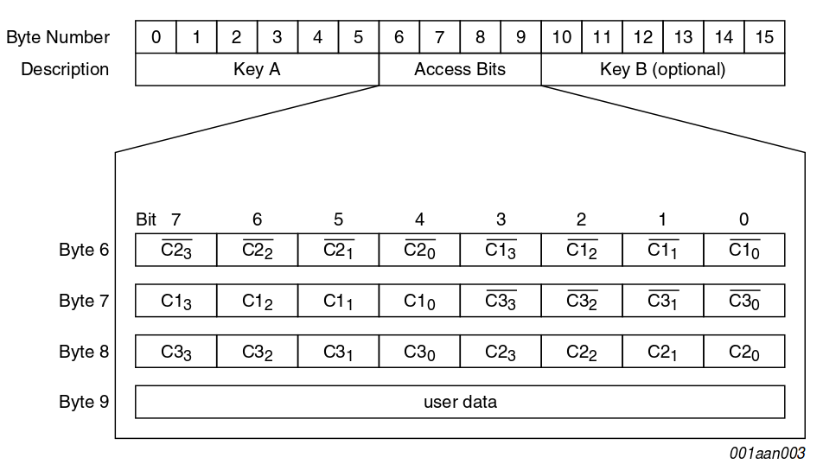

1. **Mifare Ultralight C** ([mifare](http://www.mifare.net/files/1813/9782/9174/MIFARE_Ultralight_C_.pdf)) ([nxp](http://www.nxp.com/documents/short_data_sheet/MF0ICU2_SDS.pdf)) ([Skyetek](http://www.skyetek.com/docs/m2/ultralightc.pdf))

* The first low-cost ICs for limited-use applications that offer the benefits of an open [Triple DES](http://en.wikipedia.org/wiki/Triple_DES) cryptography
* Type A; Triple DES (3 key to encrypt), Unique 7 bytes serial number
* RF 13.56 MHZ; communication speed - 106 kbit/s
* P/E Cycle - 10000
* Data Retention - 5 yrs
* Typical transaction - <35 ms (faster - 10 ms)
* Anti-collision

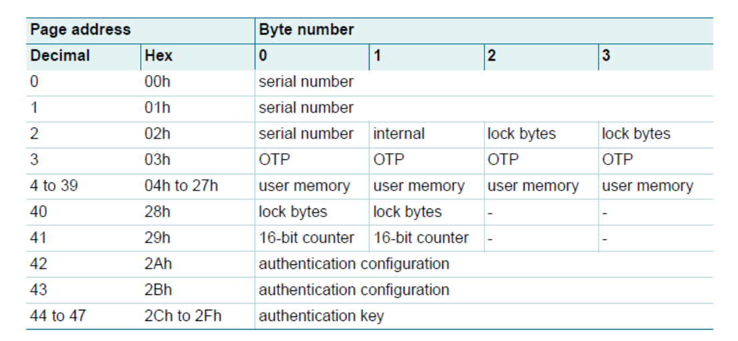

* 1536 bit (192 bytes) EEPROM, 48 pages (1 page = 4 bytes)
* UID - 7 bytes
* UID Block check character - 2 bytes
* OTP (one time programmable) area - 4 bytes
* User r/w area - 36 pages (36*4 = 144 bytes)
* Locking - 4 bytes
* Counter - 2 bytes
* Manufacturer data - 5 bytes
* Auth conf - 8 bytes
* Auth key - 16 bytes
* page 0x02 lock bytes locks 3 to 15 pages

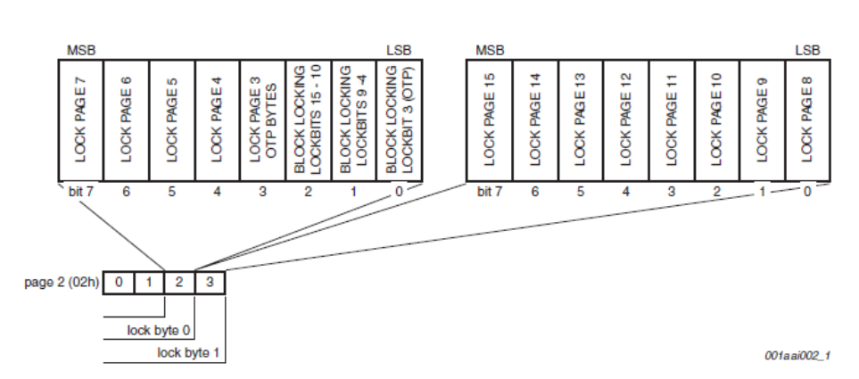

* page 0x28 locks 16 to 47 pages

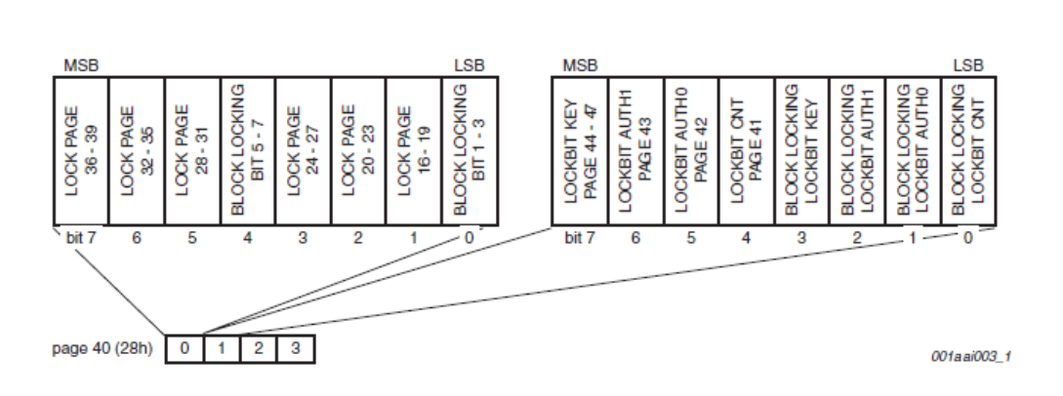

* Lock keys are irreversible
* Key1 and Key2 are stored in 44 to 47 pages

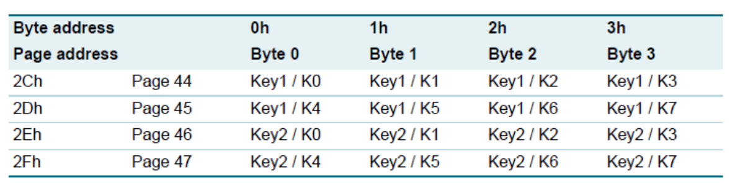

1. ISO Certification [(wiki](http://en.wikipedia.org/wiki/ISO/IEC_14443))